**Measurement of Moses 2 Surface**

June 13, 2017

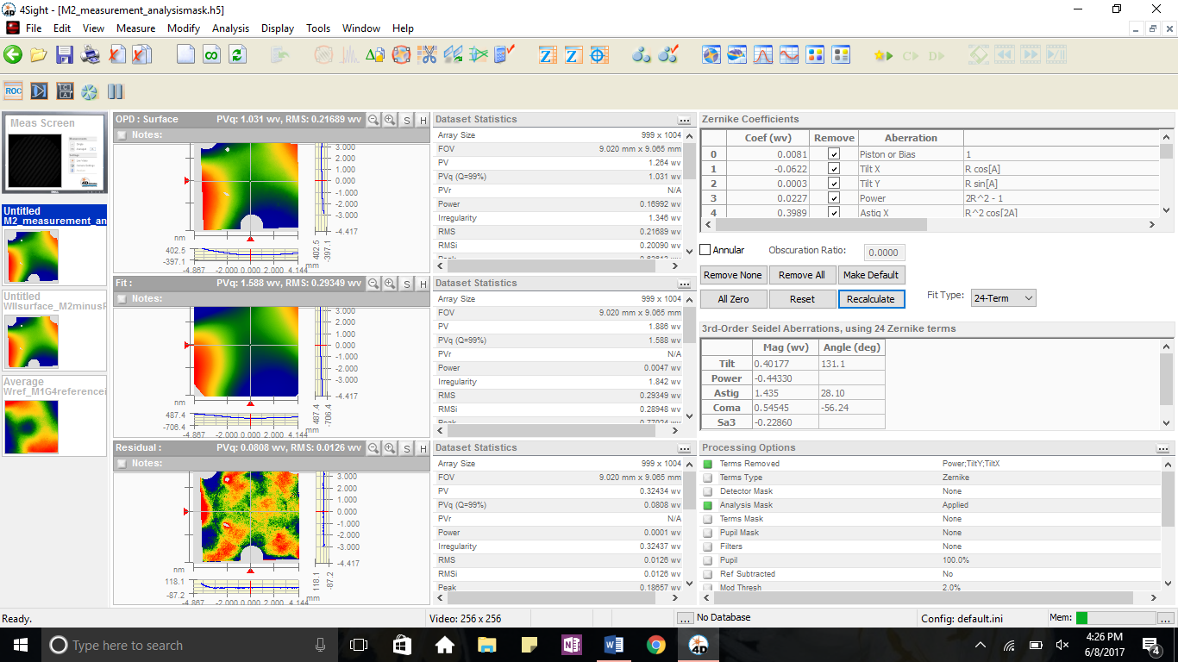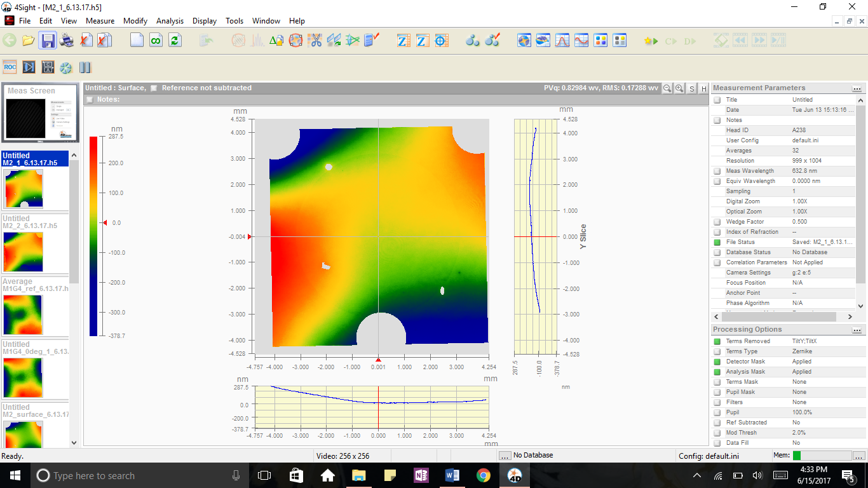

**Measurement of Moses II – WII**

An interferometer image of the Moses 2 primary mirror in its mount. The three large circles are masked bolts holding the mirror to the mount and the grey holes on the image are large dust particles on the surface of the mirror. The Zernike fit is shown on the left:

Astig X 0.2369

Astig Y 0.4310

Coma X 0.0539

Coma Y 0.0183

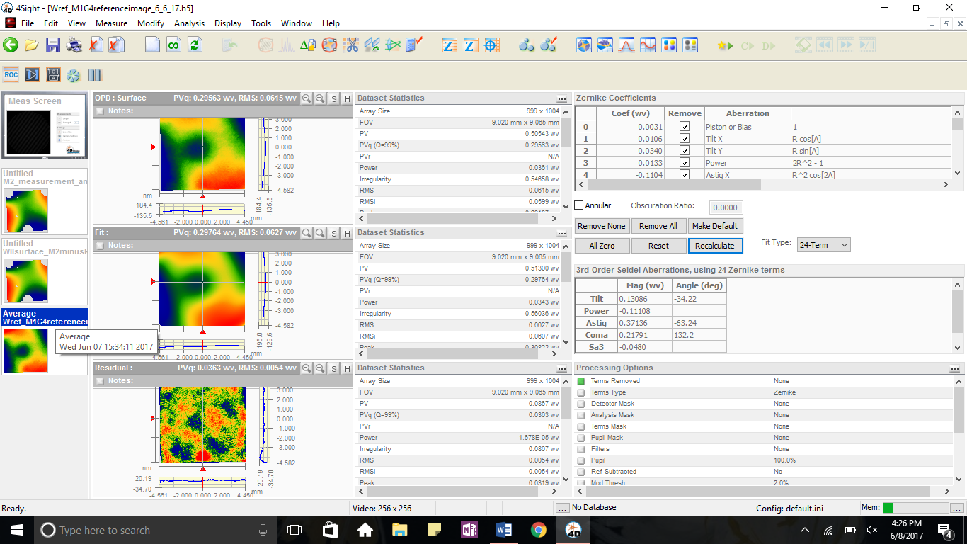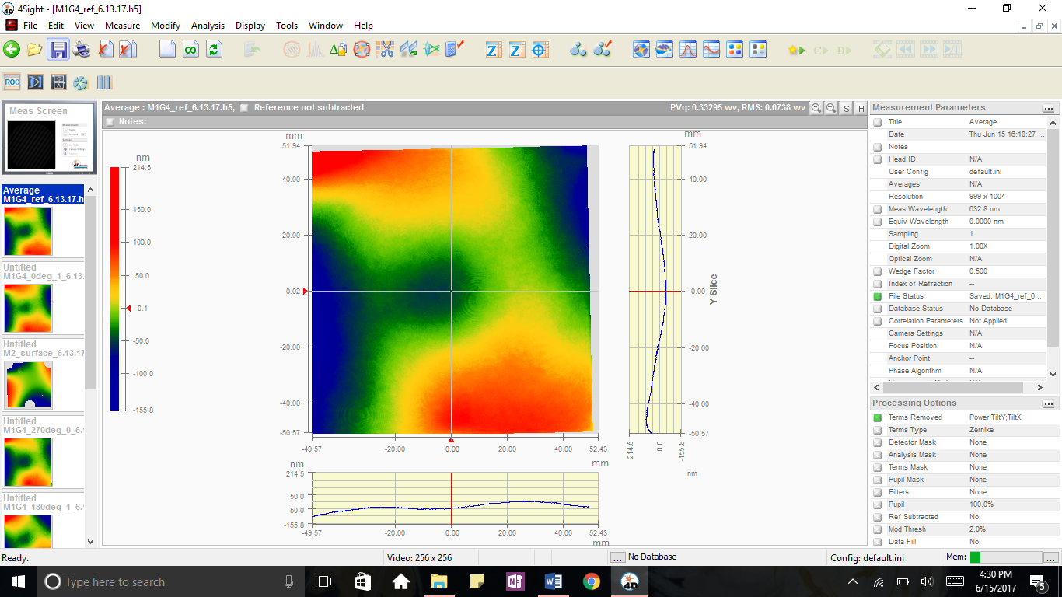

**The Reference Surface – Wref**

The four rotations of Moses 1 primary – 0 degrees, 90 degrees, 180 degrees, and 270 degrees – are averaged to form a reference surface.

Astig X -0.1405

Astig Y -0.1596

Coma X -0.0486

Coma Y 0.0810

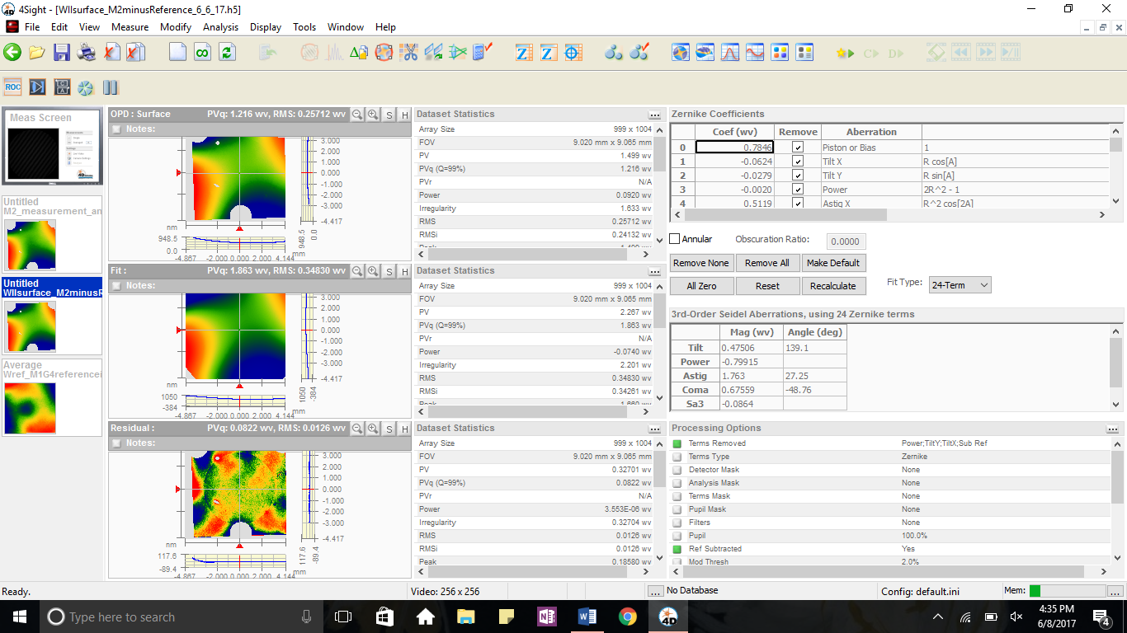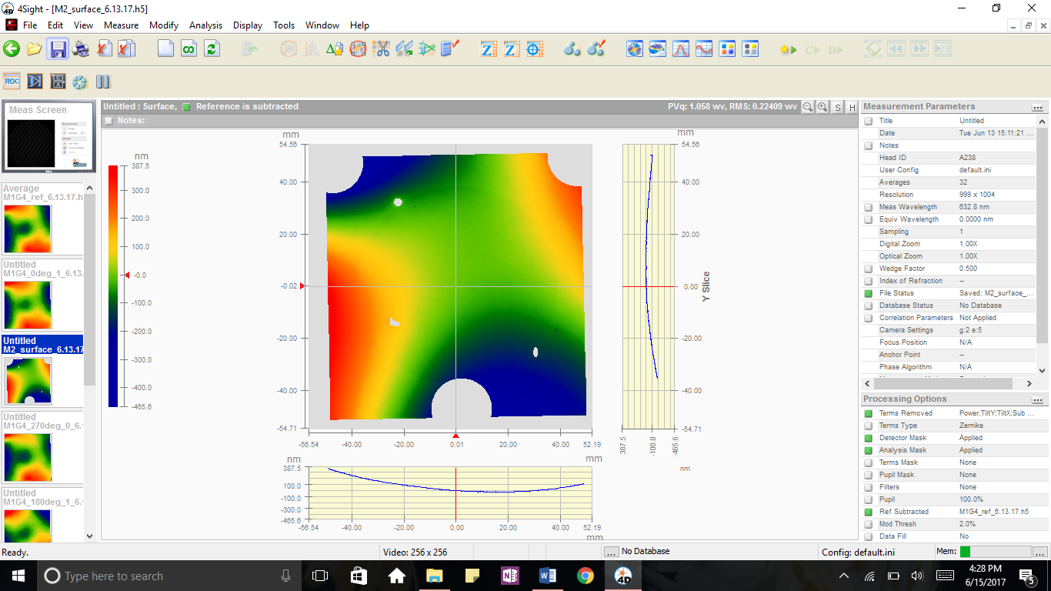

**Surface of Mirror – WIII,Surf**

For this measurement, the Wref reference surface is subtracted from the WII measurement. This gives the shape of the mirrors surface, excluding any aberrations caused by the telescope or interferometer itself.

Astig X 0.4658

Astig Y 0.5844

Coma X 0.1388

Coma Y -0.1517